**Selenium with TestNG**

Selenium is use to Automation testing for UI Component and Test NG provide set of assert method which help to check excepted and actual output.

We develop application using any language java, python, php, angular or react js etc.

Deploy the application

VM : Virtual Machine

Base Machine : Window

One machine -> One OS

One machine 🡪 We can run multiple OS.

We can run only one OS at time.

VM software

VMWare : it provide tools to run multiple os.

Oracle Virtual Box

With help of VMware software we can run abstraction version of an OS. Which help to do virtualization.

**Containerization:** with help of Docker we can create containerization application. Containerization is use to run abstract version of an application.

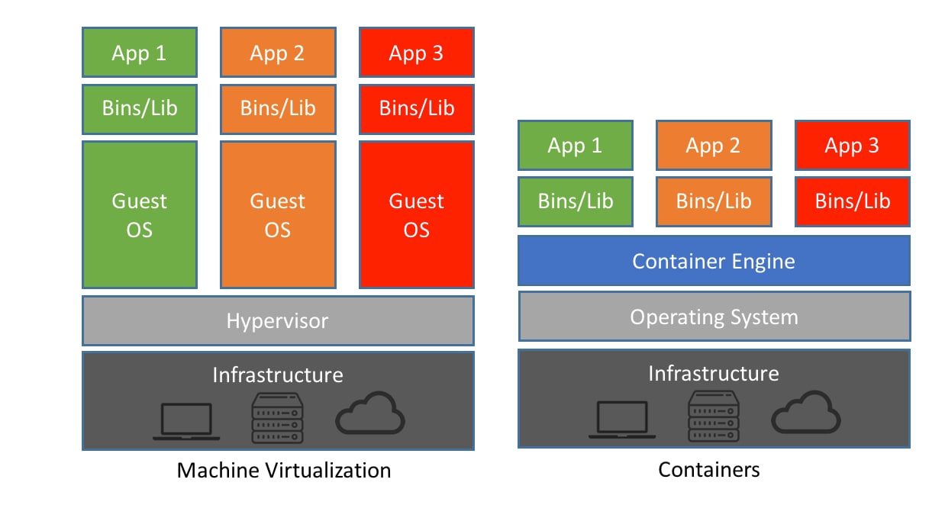

**Docker :** Docker is a platform which help developer to package the application with their dependencies into a container. Docker container is light weighted container which help to run the docker image.

Container : run time environment.

Docker image : Docker image is ready only template file which is responsible to run the application with help of container.

DockerFile : DockerFile is a type of file which contains set of instruction which help to create the image. Inside this file we need to provide application details which we want run with their dependencies.

DockerHub : DockerHub is an open source repository for docker images. We can publish or push as well as pull user defined or pre defined images.

**Docker images**

docker --version

docker info

docker images : this command show all images present in local machine.

docker pull imageName : this command pull the image from Docker hub account(by default Docker hub repository)

docker pull hello-world : hello-world is pre defined image

to run the image

docker run imageName/imageId this command is use to run the image